**HS Ruixing Attiny1617 ADC Issue**

Microchip Component: ATTINY1617-MBT-VAO

Attendees: Leo Zhang(Microchip),向玲lily.xiang@a-bit.com.cn , Liang Zhang (HW), rx-dz5@rxaes.com, Zhihui Fang (SW).

**Issue description:**

No LIN communication, OEM: LiXiang, total 18 PCs fail in 20K. Currently only 2 PCS can be reproduced, 1 PCs was reproduced at Oct (McuAdBat-PA4 port abnormal, stuck at 5V), but this samples was lost? And another sample could reproduce in few hours (3 hours) (Still McuAdBat-PA4 port abnormal). and the behavior was the PA04 (McuAdBat) input voltage was stuck at 3.5V (Normal value should be around 2.4V at 12v input with divided resistor R46-100K+R49-22K, RC Filter resistor R47 value was 10K).

R47 two side abnormal voltage was 3.1v(left) and 3.5V(right).

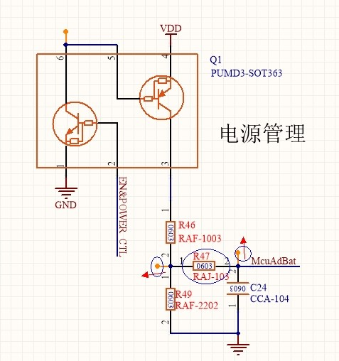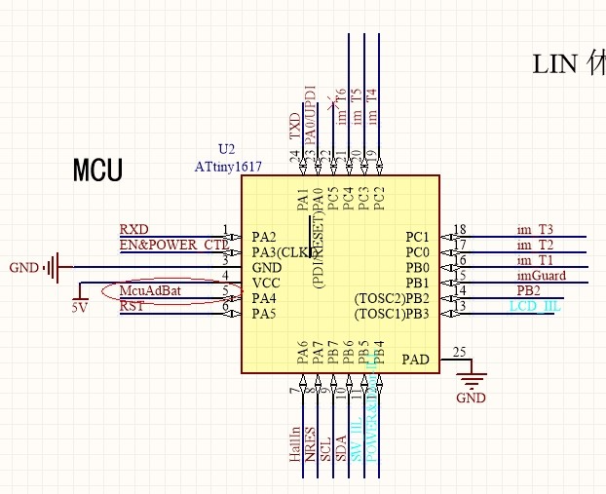

**Issue Analysis:**

From the issue behaviour, it's suspect the PA04 pull-up resistor was enabled. And it also could reproduce the same behaviour by enabled the PA04 pull-up resistor intends, the input voltage was also be 3.5V.

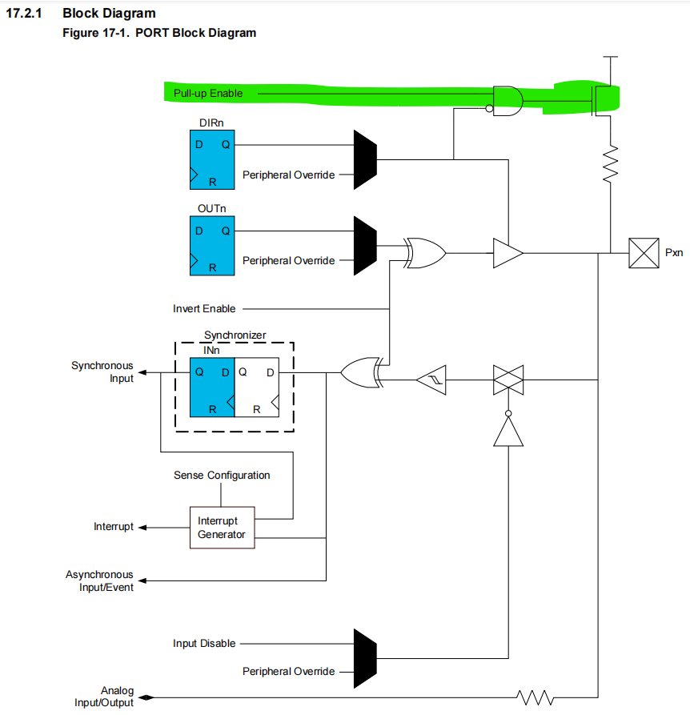

**IO Rp (Resistor Pull Up)**

IO Pull Resistor value was 35K, after divide resistor (10K+22K), the voltage at PA4 should be around 2.5V  
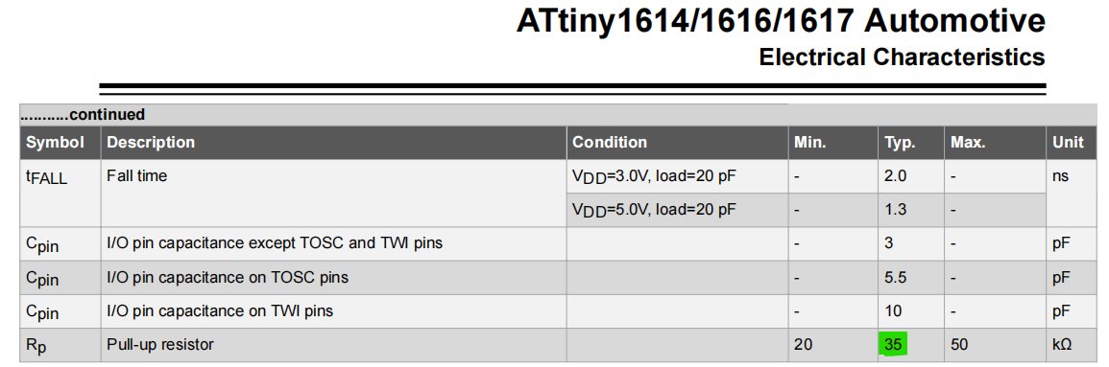

**Check List:**

1. Reproduce the issue and check if the MCU stuck at the Init function **mcu_init();** Remove the R66 and check the PB2 could help. If PB2 was 5V then the MCU should be stuck at init.  
   After test at 24/Nov, the PB2 voltage was 0V. So cannot identify the issue from the behaviors.  
   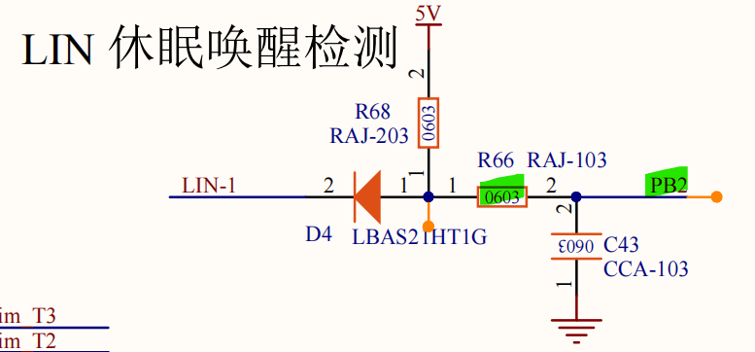
2. Sleep/Normal/Fail, compare three state current.
3. Reproduce the issue with another board with out refrigerator load, then the board could send to microchip for analysis.
4. Need Lot information for total 18PCs failed parts. This will help to check if this is a fabrication issue.
5. SW test:
   1. Remove all I2C and pull up related code (in void mcu_init(void)) for test.
   2. Set up a minimal system that can reproduce the issue. (like only port/peripheral init routine and sleep/wakeup function)
   3. Check if the SCL-PIN9-PB7 have the short with the PT16528, the PT16528 I2C slave maybe have the [I2C SCL stretching](https://prodigytechno.com/i2c-clock-stretching/), check if the high pulse length was not enough (1.25us).  
      Could reference: https://ww1.microchip.com/downloads/en/Appnotes/doc8380.pdf  
      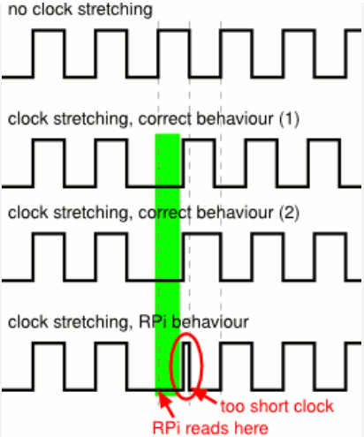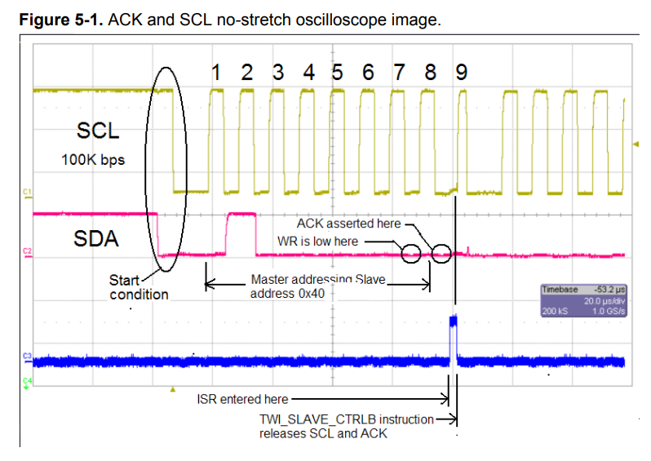
   4. ABA test.